### Getting to the IASAQ office

### How to join the ***IASAQ***

Irish Australian Support Centre

Justice Place,

5 Abingdon Street,

Woolloongabba QLD 4127

Australia

Phone: +61(07) 3391 1300

Mobile: +61(0)432 087 328

E Mail: info@iasaq.com.au

Website: www.iasaq.com.au

Train: Park Road is your Stop on the Gold Coast & Cleveland Lines

Bus: Number 116 Bus to stop 10 at Dutton Park

Walk / Drive: See map above

It is a long standing Irish & Irish Australian tradition to provide aid to others in need.

By supporting the association either through becoming a member, contributing to a current appeal or simply volunteering your time, you will be helping the association in its endeavors to help others.

*Go Raibh Mile Maith Agat*.

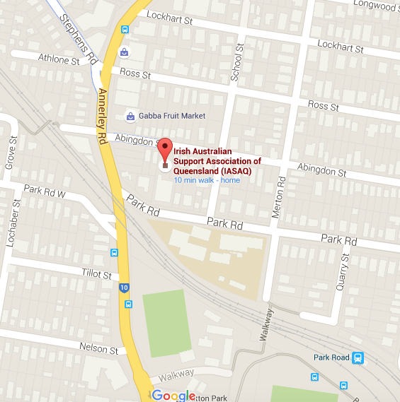

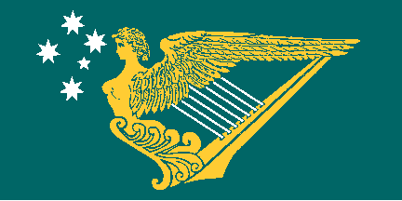Caption describing picture or graphic.

# C:\Users\Rita\Desktop\4 - IASAQ png.png **Irish Australian Support Association of Queensland Inc.**

### Membership forms are available for download via our website: www.iasaq.com.au

Or

Drop in to our office to collect one anytime between 9 a.m. to 5 p.m. Monday to Friday, a cuppa and a chat will be available to all potential applicants...!!

Or

To get one mailed out to you if you live *outside* of the greater Brisbane area.

Call the Coordinator (*Paddy Farrelly*) on:

landline (07) 3391 1300

Mobile 0432 087 328

All donations over $2.00 can be acknowledged by a tax receipt as IASAQ has full tax deductible gift recipient status

## Price List

***Seniors Luncheon***

Tea, a chat, some home cooking and a general get together. Seniors meet every second Tuesday 11a.m. to 4 p.m.at the *IASAQ* Centre, or sometimes they decide in advance to meet at a local point of interest or beauty for a lunch outing. *IASAQ* has a Minibus which can bring those with no transport of their own, to these events. Come along and bring a friend, you do not need to be a member of *IASAQ* to attend. Call the office to find out more details.

***Mothers Groups***

*IASAQ* supports two Mothers Groups in the greater Brisbane area. We have Facebook pages for the Mothers and Families groups and we are always delighted to welcome new members from the Irish and wider Irish Australian community. The Mothers groups are proving to be a great resource for young families just starting out in Queensland and for more established families who just want to connect. Contact the office or find us on Facebook for more details.

***The******IASAQ Centre would be pleased to help you with any of the following:***

* Services to the elderly
* Family and Personal Services
* Health Services
* Social and Welfare Services
* Housing and Accommodation Problems
* Unemployment Issues and Problems
* Leisure and Recreation facilities
* Irish and UK Passport applications
* Funeral Arrangements
* Repatriation of deceased persons to Ireland
* Clubs and organizations in the community
* Helping you to make contacts and to settle in Brisbane or Queensland
* Language and Cultural activities
* Volunteers to visit people in their homes, Hospitals or in Prison

The Irish Australian Support Association of QLD Inc. is a non-profit voluntary organization whose aims are to assist, where possible, any person or persons, from the Irish Australian community who may be in distress.

We do not give direct financial aid. However we will help with appeals for financial help in appropriate circumstances as deemed by the Board.

We will, where possible, help with temporary accommodation, casual or full time job referrals and advice, loss of passports etc. We will also try to provide advice on all the different problems and difficulties that can arise in life.

We are a referral agency and are happy to advise which Government Department or Charitable organization is most suited to your needs.

There is a complete list of our services on this page.

We also provide a friendly and non-judgmental voice from home, a cup of tea or coffee, a smile and a friendly chat for all visitors.